DAY 4 LAB EXPERIMENTS

NAME : VIGNESHVAR S
Reg No : 192424187
DATE : 19/12/2025

EXP_16 To Develop a Python Rrogram to Calculate the frequency distribution of words in the customer reviews Dataset
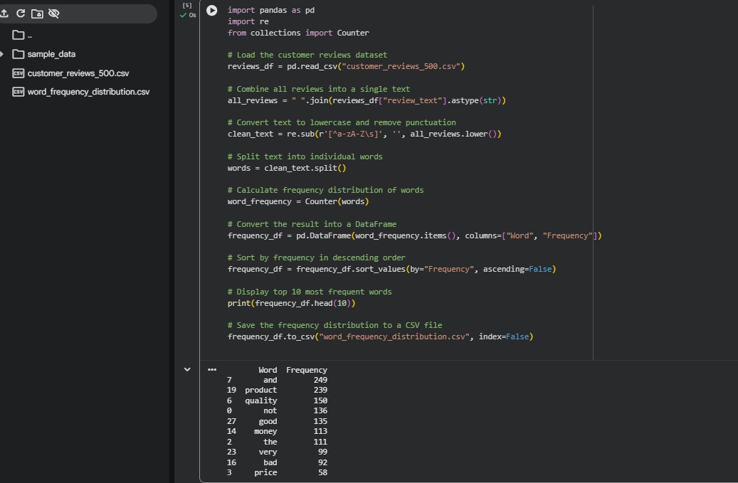

EXP_17 Your team has collected a large dataset containing customer feedback from various social media platforms. The dataset consists of thousands of text entries, and your task is to develop a Python program to analyze the frequency distribution of words in this dataset.
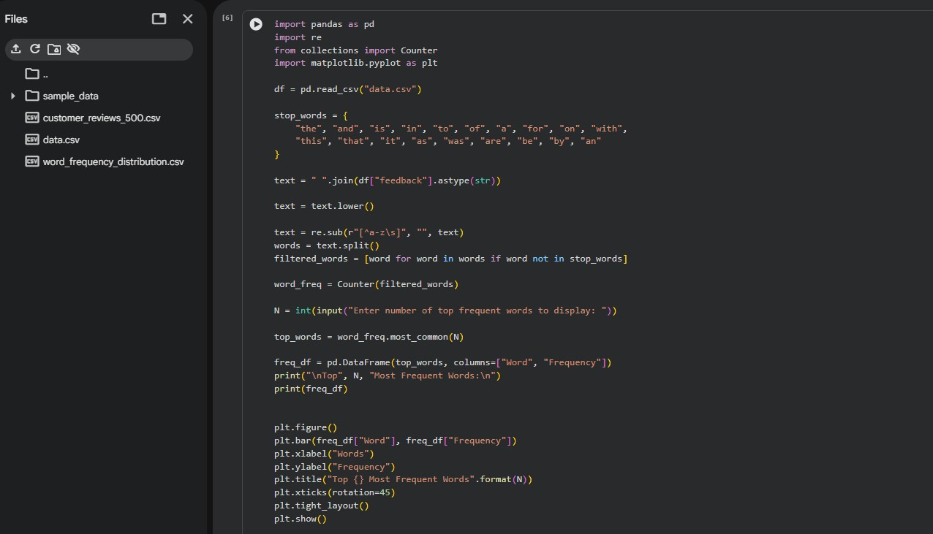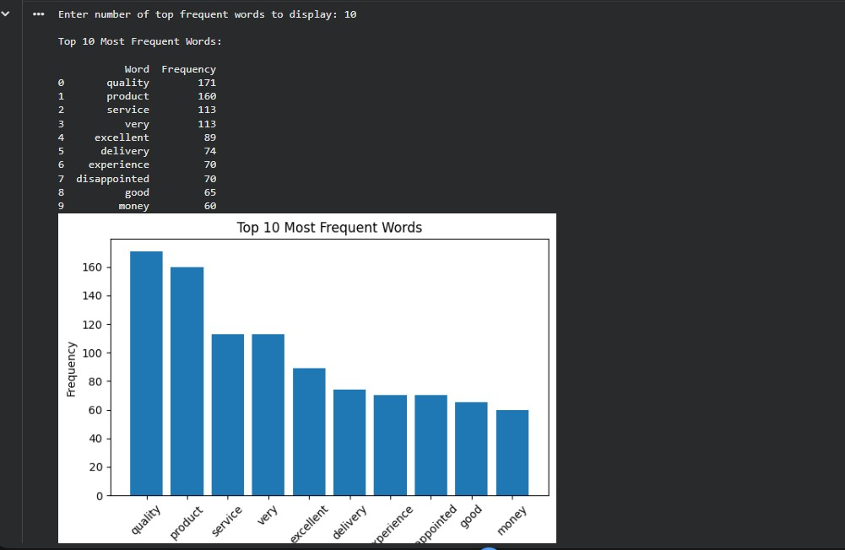

EXP_18 Suppose a hospital tested the age and body fat data for 18 randomly selected adults with the following result.
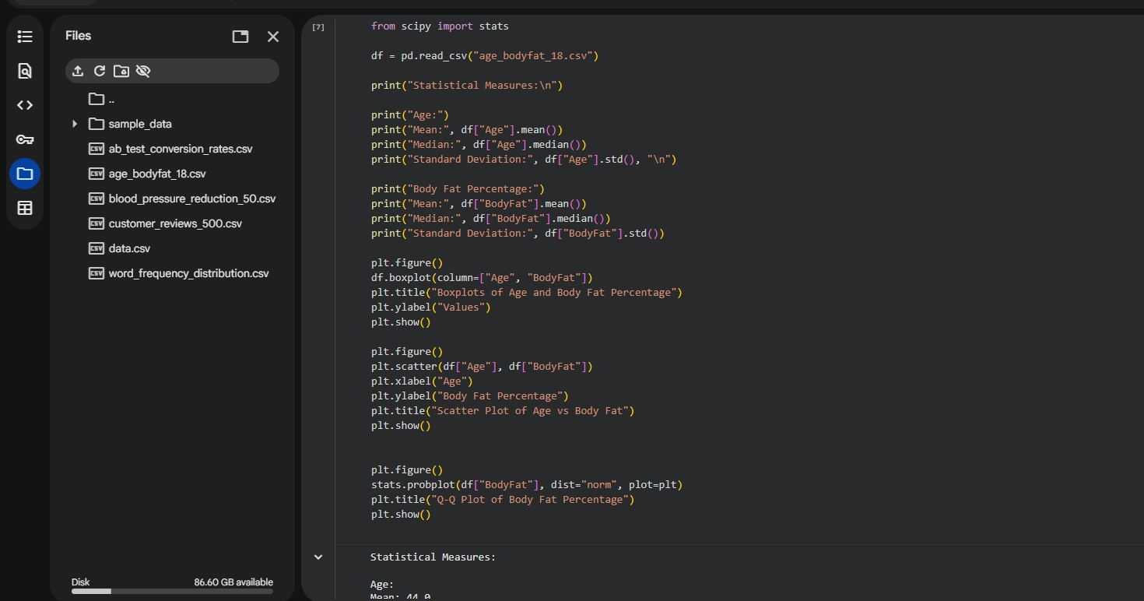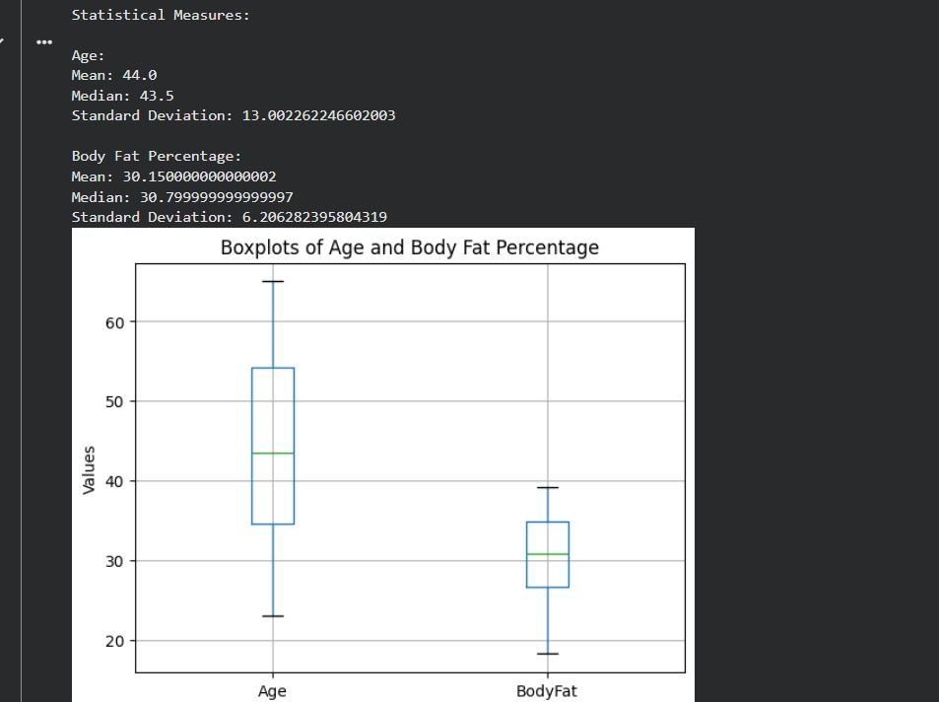

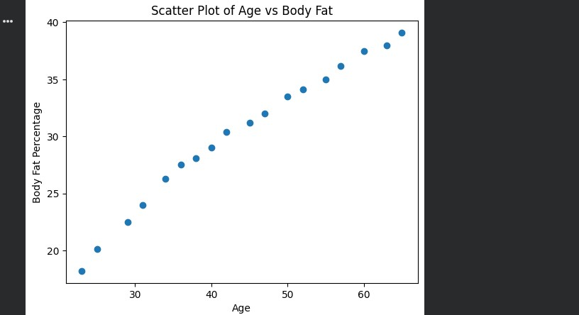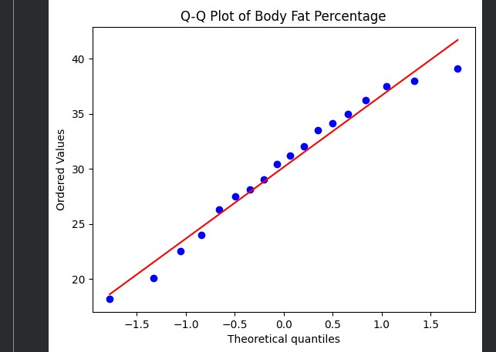

EXP_19 Suppose a hospital tested the age and body fat data for 18 randomly selected adults with the following result.
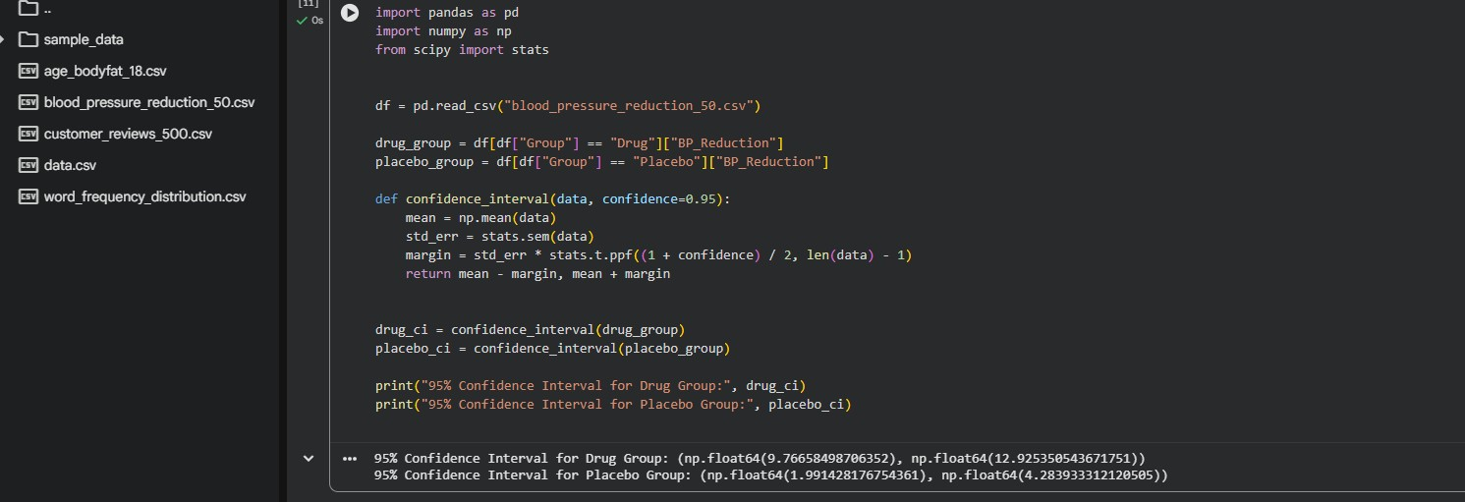

EXP_20 The marketing team has conducted an A/B test to evaluate the effectiveness of two different website designs (A and B) in terms of conversion rate. They randomly divided the website visitors into two groups, with one group experiencing design A and the other experiencing design B. After a week of data collection, you now have the conversion rate data for both groups.
